Assignment 2
Name: Mangeshkumar Shah
Roll No.: 22101B0045

STEPS:
- First fork the repository and then clone it.

- Clone the Repo
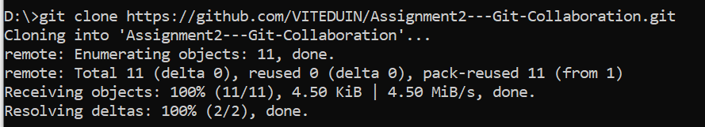

- Go to the cloned directory
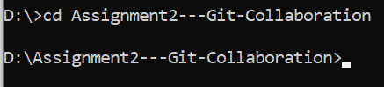

- Check status and branch
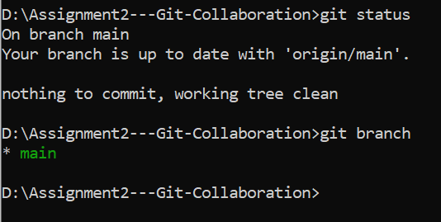

- Create your branch
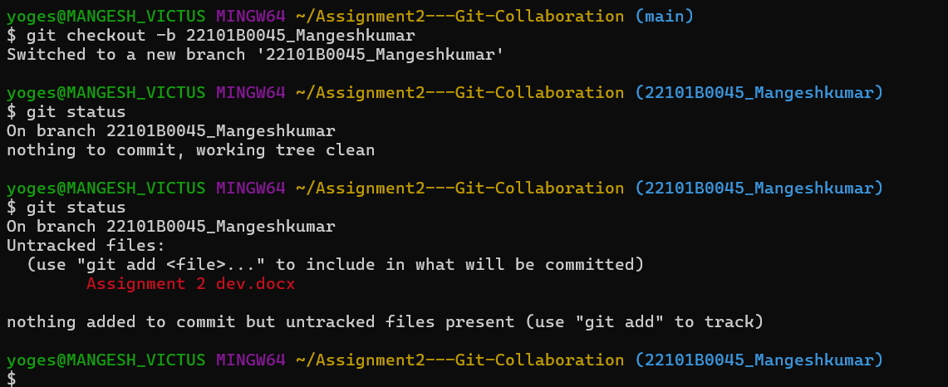
- Add files to staging area.
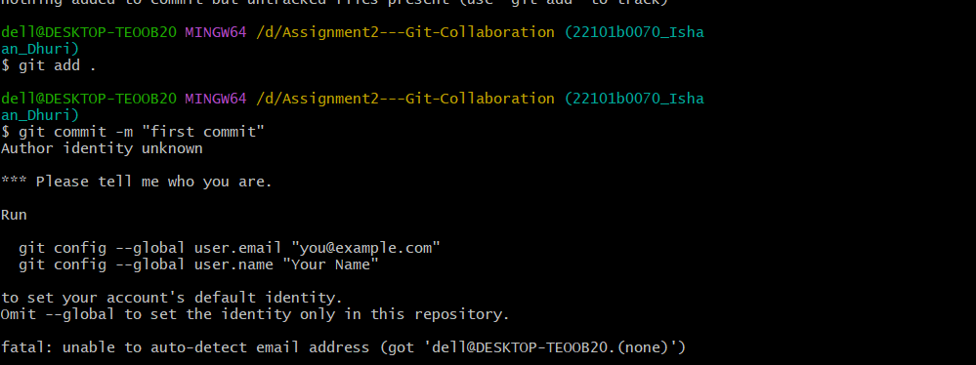
- Files added.
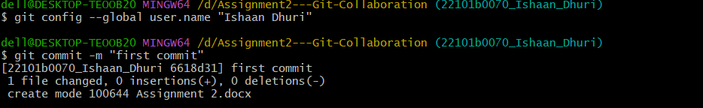
- Commit the Changes

- Push the branch to GitHub.
